Assignment 5
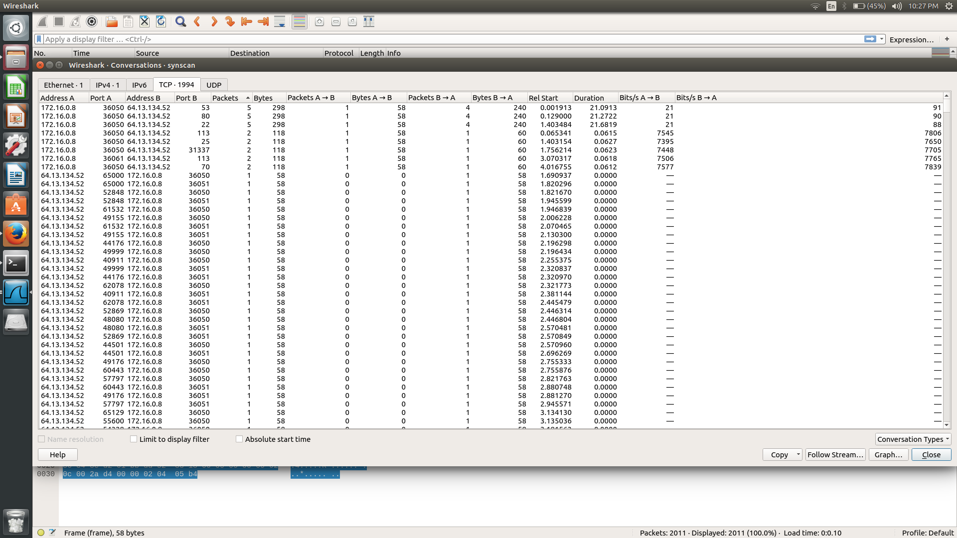
synscan.pcapng
The aim of this assignment is to find out which ports are open and which are closed. One way to this, is to check the number of packets sent between the host and the destination. For example, as can be seen in the screenshot below, the ports can be divided into 3 categories based on the number of packets exchanged during the conversation. These three categories are conversations with 5,2 and 1 packet(s) respectively.

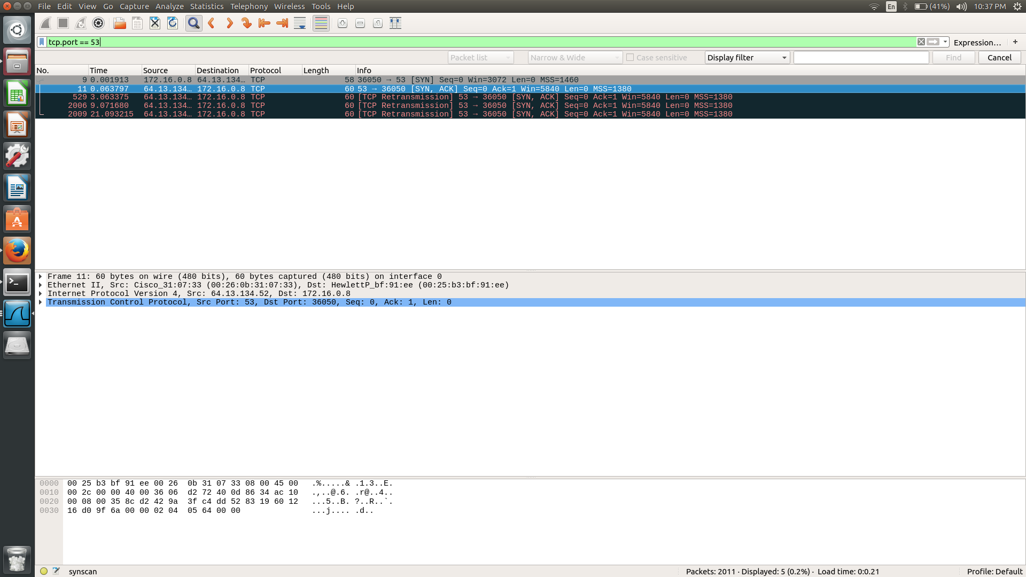
Consider port 53 in which 5 packets are being exchanged in the conversation. It can be seen that the attacker sends a syn scan to the port. The port acknowledges and sends a syn to the attacker. Now the attacker knows the port is open and hence does not complete the handshake process with the port even though the port itself attempts varioues retransmissions. This is the case for ports 80 and 22 as well.

Consider port 113 in which 2 packets are being exchanged in the conversation. The attacker sends a syn scan. The port responds with an RST (reset flag) indicating that it is closed. This is the case for ports 25, 31337 and 70 as well.

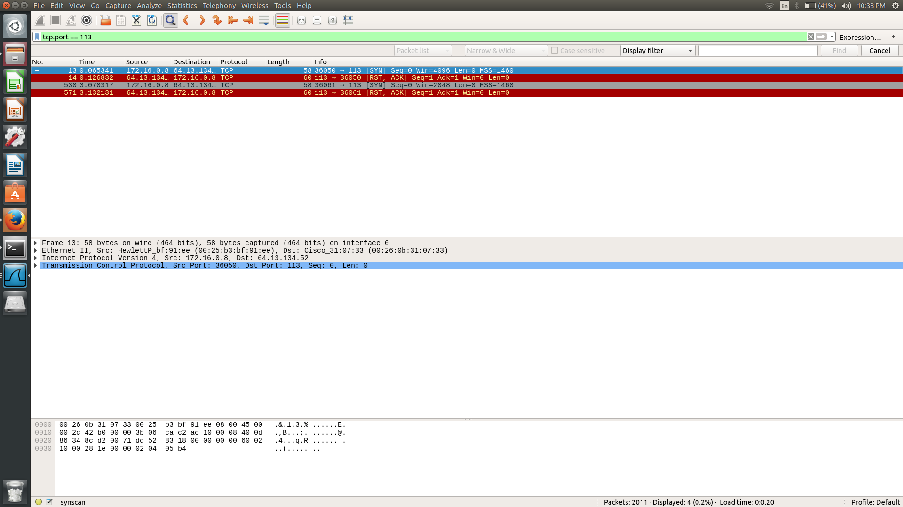

Lastly, let us consider port 36050. Only one packet was exhanged in the conversation. From the screenshot, it can be seen that the attacker sends multiple syn scans to the port however there is absolutely no response from the port indicating that it is closed. All the remaining ports come under this category and are closed.

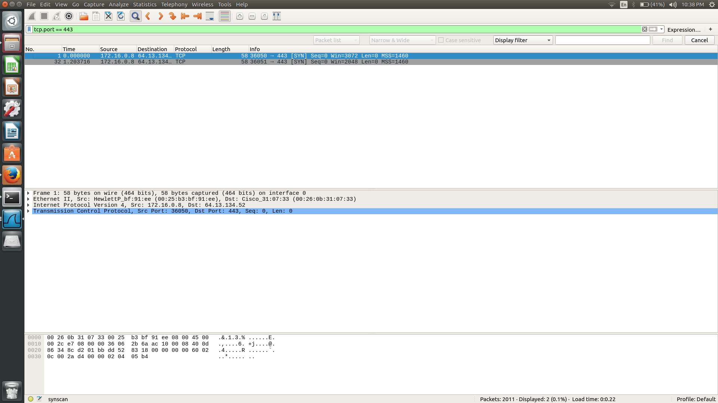

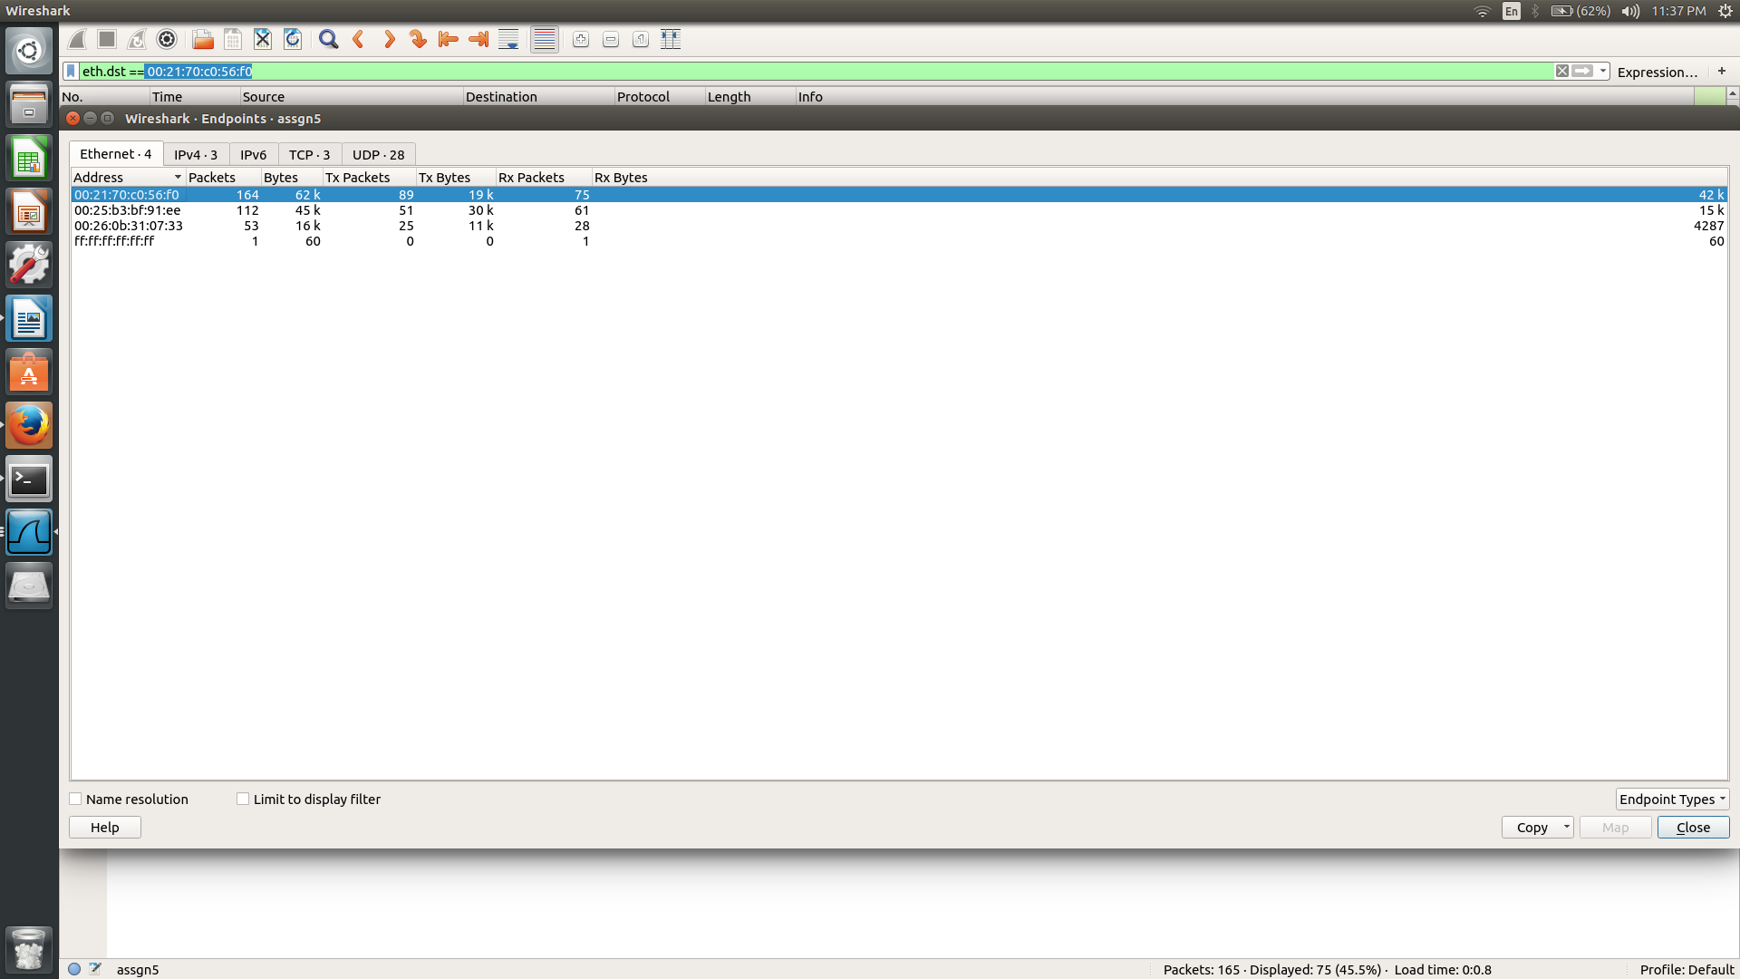
assgn5.pcang
This is an example of a man in the middle attack. In a MITM attack, an attacker redirects traffic between two hosts in order to intercept or modify data in transmit. The MAC addresses indicate that the communicating devices have Dell and Cisco hardware.
The HTTP traffic all appears to be (classic HTTP) Google searches. The DNS traffic all goes to the 12 address and none of the responses look odd or reference any 172 addresses.

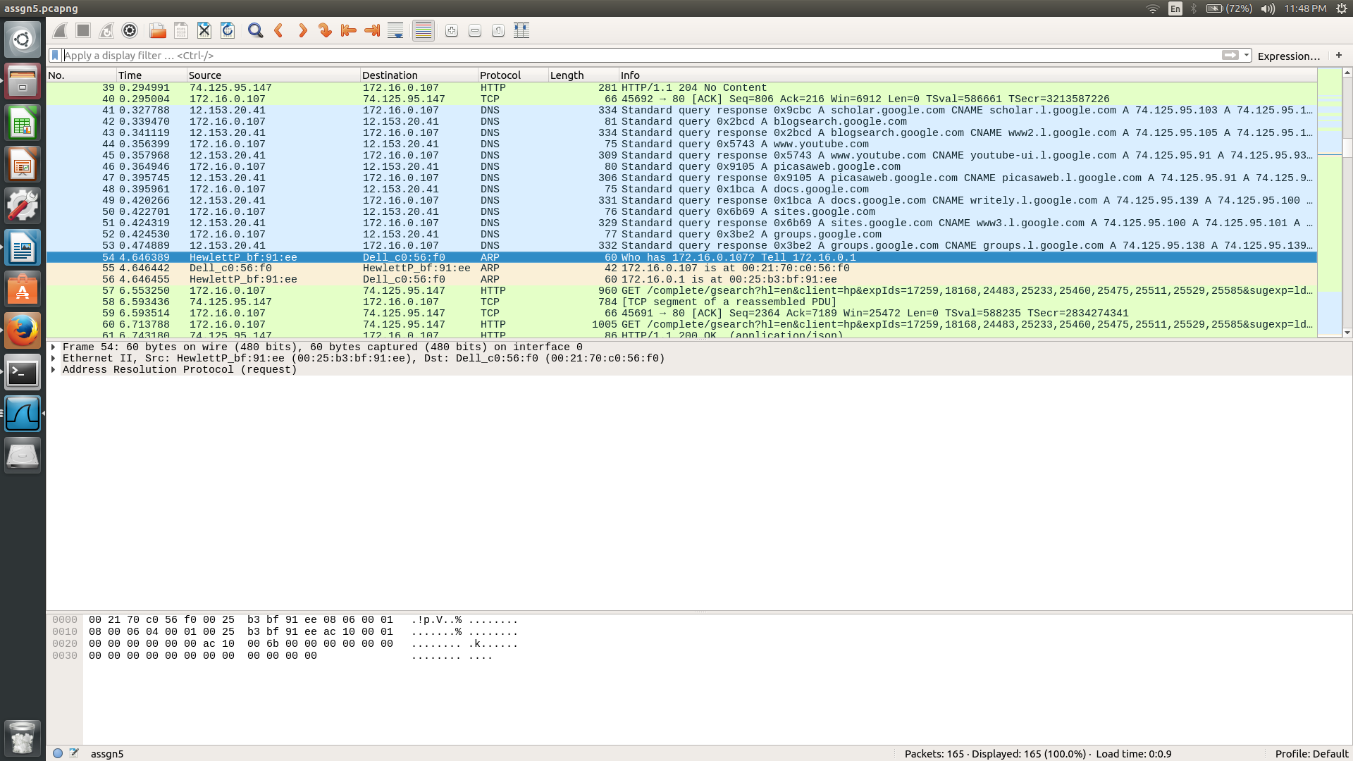
Packet 54 is an ARP request sent from the attacker 00:25:b3:bf:91:ee to the target 00:21:70:c0:56:f0 . Normally Arp packets should be broadcastd but this one is directly to the target only.
This is followed by a response from target to attacker that has its MAC address info. In packet 56, the attacker sends a packet to the target with a ARP reply saying that 172.16.0.1 is located at mac adddress 00:25:b3:bf:91:ee. However, 172.16..0.1 is actually 00:26:0b:31:07:33. Because of this, the target will be sending all the info it was supposed to send to the router, to the attacker.

